Download your pupil information from your MIS in to an xls document. No tabs, just one long list with all classes and pupils. Save it to your desktop. The tool will require 4 columns for primary and 5 columns for secondary, per the list visuals on the left and right of Fig 1 below.
- Select your primary or secondary status. Fig 1:
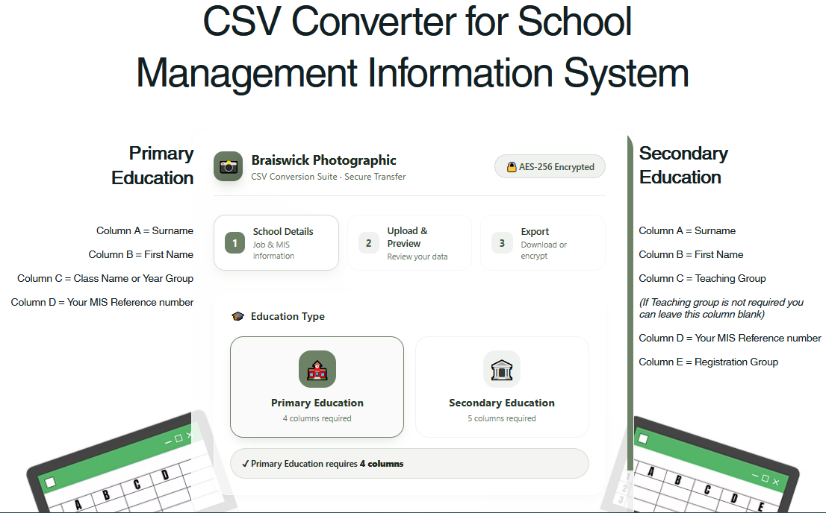
- Now input your Job number or postcode, School name & MIS provider per Fig 2:
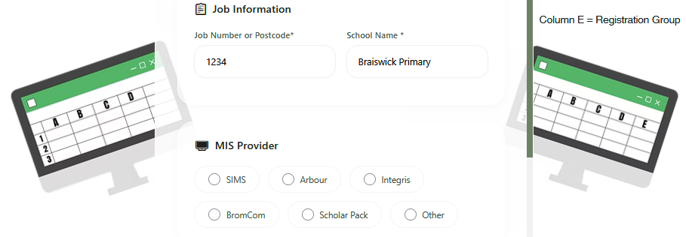

- Drag & drop your spreadsheet or click to browse to locate from your desktop. Per Fig 3:
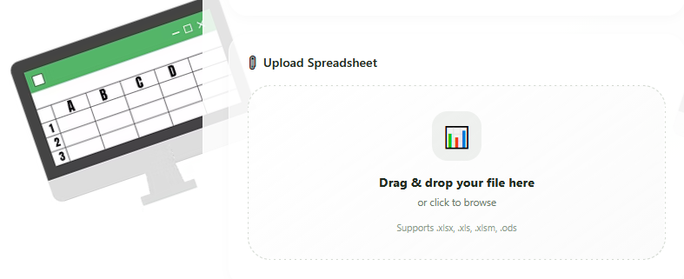
- Check Data Preview. If happy all columns are present, then click on the ‘Download CSV Zip button. Fig 4:
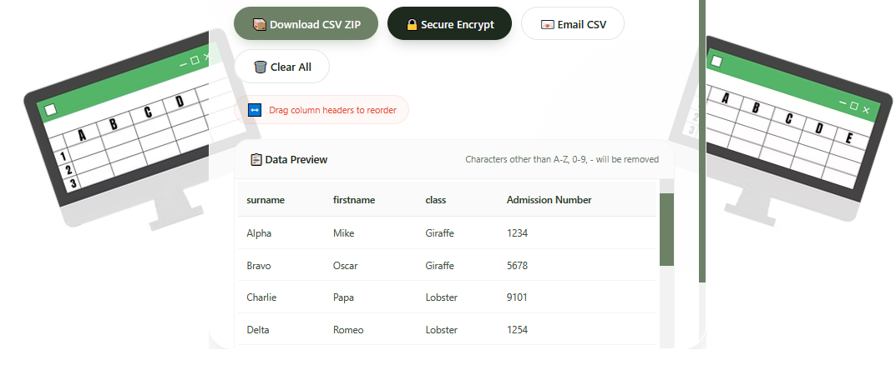
- This will download to your computer, you will get the following confirmation, click OK. Locate the file and place it on your desktop. Control J is a fast way of obtaining the Zip folder from your browser. Fig 5:
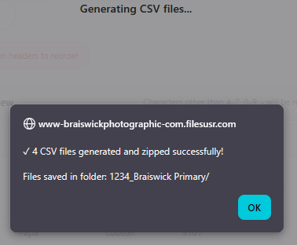 | 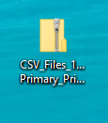  Desktop Visual

- Open a new email using your email Client (Outlook, Gmail etc). Using the Braiswick tool click on the Email CSV button. Fig 6:
- This will share the necessary details for your email. Copy the details one by one, pasting into your new email. Most importantly, attach your zip file. Your email should look like this: Fig 7:
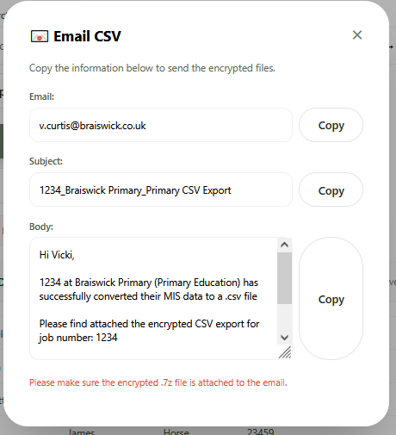 | 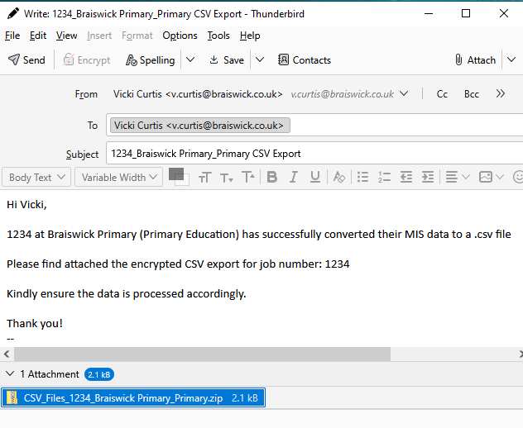

- Click ‘Send’ and you’re done.

